**3.21**

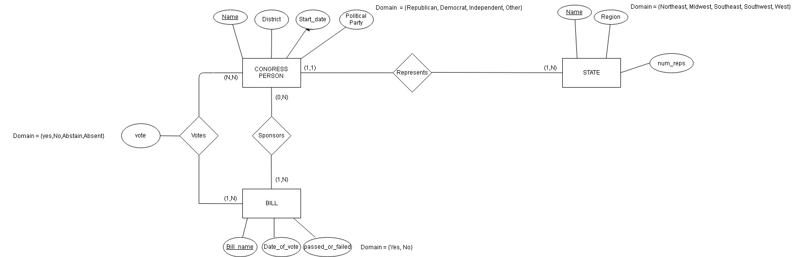

**________________________________________________________________________________________________**

**3.33**

